NIHVA TECHNOLOGIES PVT. LTD.
187, G-Block, Thermax chowk, Above Renault Showroom, MIDC
Chinchwad, Pune – 411019.

Contact Person: Mr. Mayur Derle
Mob No.: 7709209333
Web: http://www.nihva.com

AUTOMATION SOLUTION-DIVISION

Ordnance Factory :- Tail Unit Assembly- Part 3

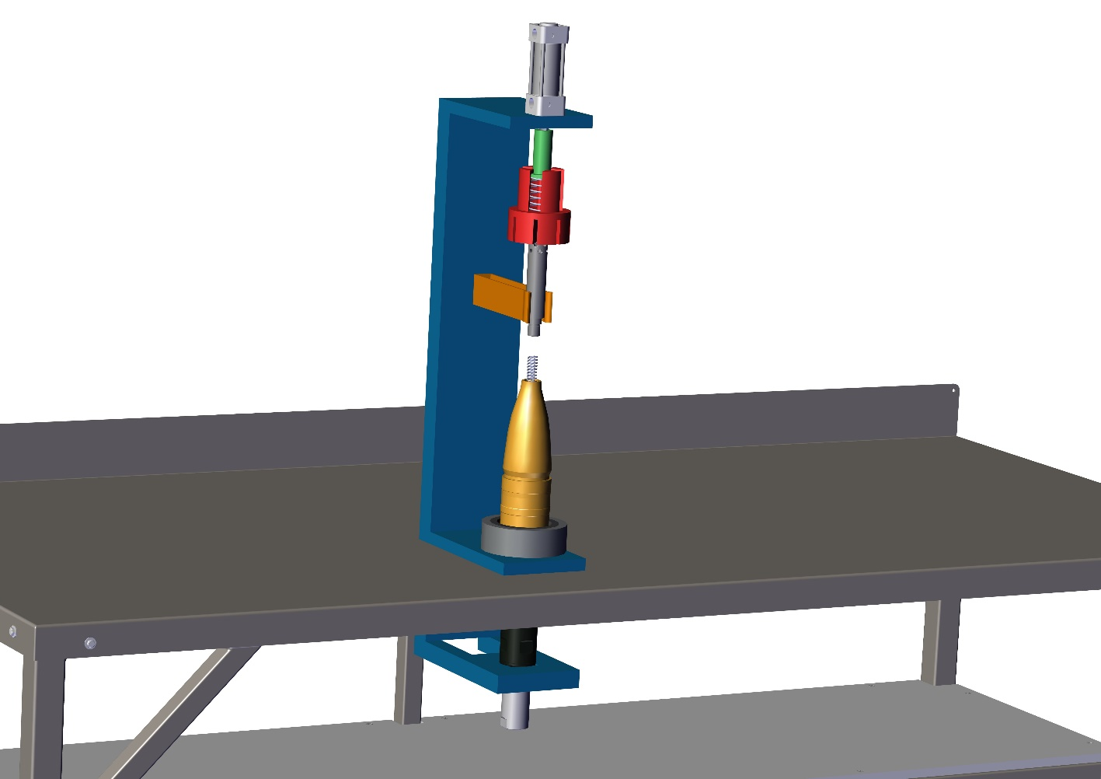

Date:

To,

Ordnance Factory
Dehuroad, Pune-412101

Kind Attention: Mr. T.K. Panda

Dear Sir,

Thank you for giving us an opportunity to participate with our offer on the above project. We enclose here with our proposal includes:

- Requirement
- Scope of Works
- Drawing, Training & warranty
- Details of Application
- Commercial
- Technical Specification
- Terms & conditions

- Requirement
- Energy efficient Design: The system should be energy efficient. The design shall ensure minimum possible power.
- Reduced Manpower: All the operations will perform by machine automatically, except placing of tail to the headstock and removing of ready shell. So this system will require minimum labour work.

- Scope of work:

The scope of work shall be exclusively on Tail Unit Assembly. This includes following work.

1.Material handling will be done manually.
2.Tail unit will be placed manually into the headstock & shell into the cavity as spring inserted condition.
3. After that tightening of tail to the shell & spring Pressing will done automatically.
4. After tightening of tail the ready shell will remove from cavity by worker.

For the above scope, following set of activities are expected to be performed:

NIHVA Automation Services Scope of supply:

Tail Assembly System Includes following:

- Design
- Manufacturing
- Successful Trails at our end
- Dispatch at your ends.
- Installation & Commissioning @ ORDNANCE FACTORY DEHURAOD
- Operator & Maintenance Training.
- Warranty of the equipment for 1 year from commissioning date.
- Hard & Soft Copy of Operator & Maintenance Manual

- Drawing:

We will issue a full set of shop drawings for approval within 2 weeks of receiving the confirmed
order and finalized design details.

- Training:

After installation of the automation system, we will train the Clients personnel in the operation and basic maintenance, including the understanding of the error codes on the control system (if applicable).

- Warranty:

The warranty period is twelve months from the date of installation and commissioning.

If a defect arises within the warranty period stated, which is attributable to faulty design,
materials or installation workmanship the product will be repaired at our discretion without
charge. This guarantee is subject to proper use of the product and assumes that the product is
regularly serviced and maintained by skilled personnel in accordance with the operation and
maintenance instructions supplied.

- Maintenance & Service Agreement:

We would suggest that you take advantage of a maintenance and service agreement on the NIHVA products, which will guarantee trouble free operation and speed of response in an emergency. Customized proposals are available on request

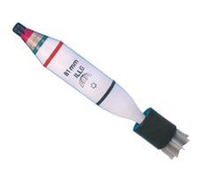

- Details of Application:

- Components Details

- Work piece Description: - Shell & Tail
- Weight: - 4 kg approx.
- Diameter: - 81 mm

Concept Image of Shell

- Commercial:

Tail Unit Assembly

Sr. No | Description | Qty | Price in  INR/Each | Total Amount  In INR
1. | Pneumatic Cylinder | 1 | 1,92,968.75 | 1,92,968.75
2. | Pneumatic Circuit | 1 | 1,92,968.75 | 1,92,968.75
3. | Installation & Transportation Charges | 1 | 1,92,968.75 | 1,92,968.75
 | GST 28% |  | 54,031.25 | 54,031.25
 | Total Amount |  |  | 2,47,000

GST PUNE | 27AAECN0437H1ZM |  | Amount in Words
GST GUJRAT | 24AAECN0437H1ZS |  | Rupees Two Lacs Forty Seven Thousand  Only

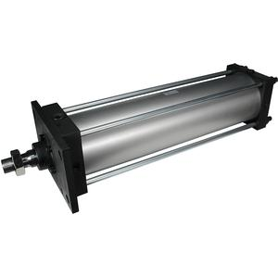
- Technical Specification:

- Pneumatic Cylinder

- Safety features

- In case of sudden power cut off, system will stand as it is until reset.
- FEA will be conducted for critical elements.
- Secondary Safety chain catch to prevent accidental drop off.
- Test Certificate will be provided for whole system.

- Terms and Conditions:
- Price  - P & F Charges  - Freight Notes  - Delivery  - Payment  - Insurance  - Tax: GST  - Validity  - Warranty | : Ex. Works Pune  : Included in above price.  : Included in above price.  : within 7-8 weeks from the date of receipt of confirmed purchase order, Advance Payment, Drawing approval.  :80% Advance along with Confirmed Purchase Order & Balance before dispatch.  : Extra as applicable.  : 28% GST.  :15 days from the date of quotation  :12 Months from the date of supply.

Please feel free to Contact Mr. Mayur Derle on 7709209333 For any further Clarification in this Concern.
With Best Regards,
Pooja Badre
Nihva Technologies Pvt Ltd

